 | Safe | Responsible | Respectful
Loading the Bus  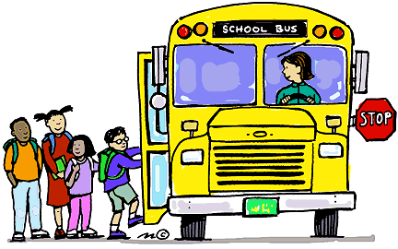 | -Stay 10 feet away from roadway when waiting for bus  -Wait for driver to give signal to board bus.  -Cross street in front of bus when signaled by bus driver.  -Load single file, using handrail  -Quickly find assigned seat | --Be on time (5 minutes early)  -Eat & drink before boarding the bus  -Keep hands, feet & objects to self  -All personal items must be secured in backpack | -Be kind and polite to bus driver and others  -Quickly find your assigned seat  -Allow personal space between you and the person in front of you (hula hoop)
Riding the Bus  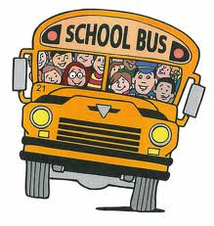 | -Always remain seated, seat to seat, back-to-back, face forward, feet on floor and hands to self  - Always buckle up  -Keep all body parts inside of the bus.  -Keep aisle clear | - Keep all belongings in lap inside backpack  -Keep area clean  -Report any damage or problems to the driver  -No eating or drinking on the bus | -Use voice level 1-2 only  -Follow Bus Driver directions  -Use positive words and actions  -Share your seat with others
Unloading the Bus  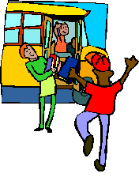 | -Stay seated until driver signals to unload.  -Cross street in front of bus only when signaled by bus driver to cross street  -Unload single file using handrail  -Quickly walk 10 feet away from bus staying in view of driver | -Gather personal belonging before your stop, take all item  -Watch driver for signal to cross street, watching also for traffic  -Unload front to back using walking feet and holding handrail  -Report any damage, concerns, or problems to driver | -Unload front seats first and then each row after that, single file  -Be patient and allow personal space between you and the person in front of you  -Help your fellow riders

